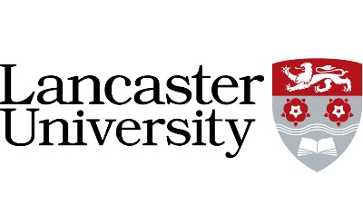

2024/25

Branded merchandise guidelines

Branded merchandise guidelines
In line with sustainability being one of Lancaster University’s key values, this should be considered in all marketing and events at the University.
When it comes to branded merchandise, these are the three key questions to consider:
- Before you order, consider whether giving away items is essential. Instead of Open Day event freebies or visitor gifts, pledge to the student hardship fund or commit to planting a tree on campus.
- Alongside the donation ideas mentioned above, the University Food & Dining Team can also make branded biscuits for an event. Order these through catering. These are made on-site and can feature a logo or design on top.
- Consider the environmental/ethical impact of your product choice. The design should be kept generic so you can use it at other events too and avoid waste. Make it something that they will use – and not throw away. Everything must have sustainable credentials.

How to order
Over 50% of the University’s carbon emissions come from goods and services we buy, so the Procurement Team have worked with the below two suppliers to ensure their sustainability credentials. Avoid choosing other online suppliers as we cannot vouch for their ethical credentials.
Allwag Branded Merchandise - sales@allwag.co.uk
Promotional Gods (Lancaster) - sales@promotionalgods.co.uk

Products – merchandise
All the products shown below are available to view in ReStore and can be ordered from Allwag (except the stickers). The duck shown below is the only version that should be ordered and is only available through Allwag.
All the items below have been carefully chosen for their sustainable credentials as they are either made from recycled materials or are biodegradable.
If you have any questions or feedback, please email marketing-office@lancaster.ac.uk

Products – VIP gifts
We have a small range of VIP gifts that you can see in the ReStore Lancaster shop on campus. These can be ordered through Allwag - or speak to Emily Rawcliffe in ReStore for stock on campus. You can also see our range of locally made design-led merchandise, available in ReStore.

Products – clothing
When requesting branded clothing items, please consider the following:
- Try not to use specific wording on the items so that it can be reused as much as possible.
- The design will be the university logo embroidered on the front left chest and a 1 colour print on the back.
- Clothing items must be made in white, black, red, light grey and dark grey to be similar to the University colour palette.
- All clothing should be organic cotton or sustainable cotton wherever possible.
- Available in white, black, red, light grey and dark grey
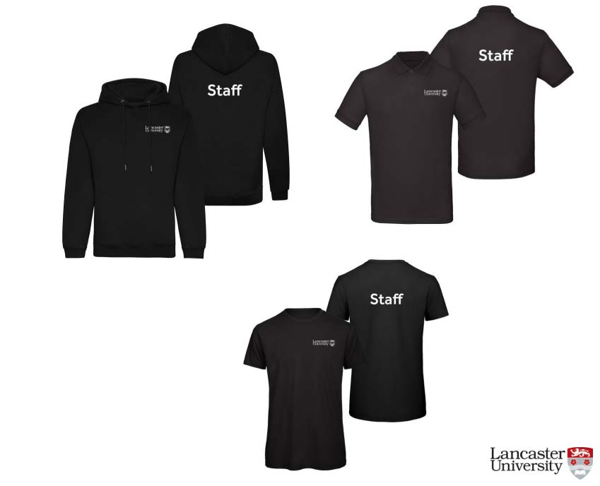
Figure 1 - Example of branded clothing items for staff at an event

