IMPART - Relatives Demographic Questionnaire
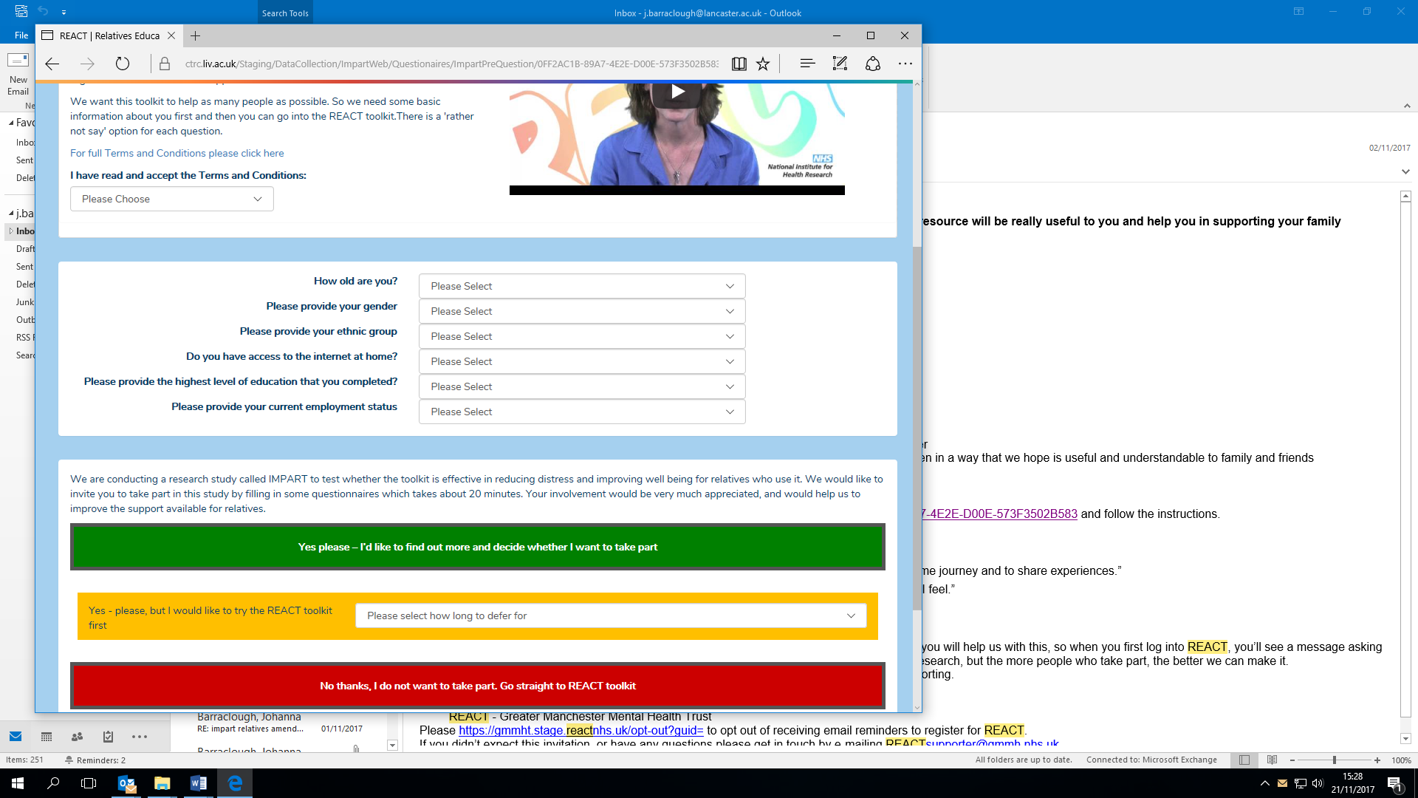
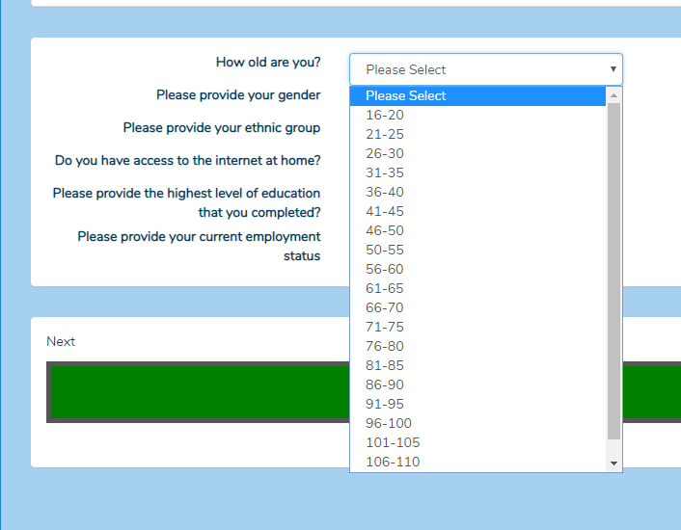
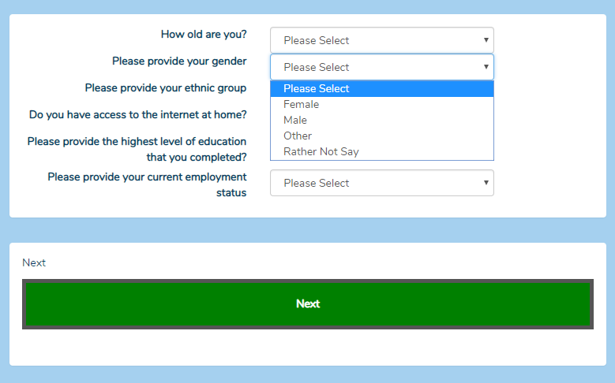
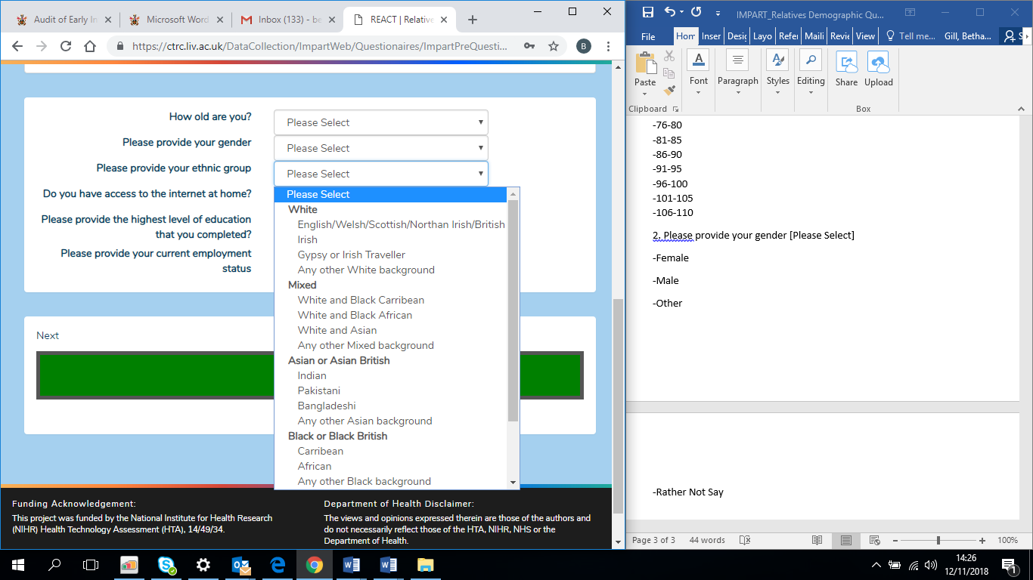
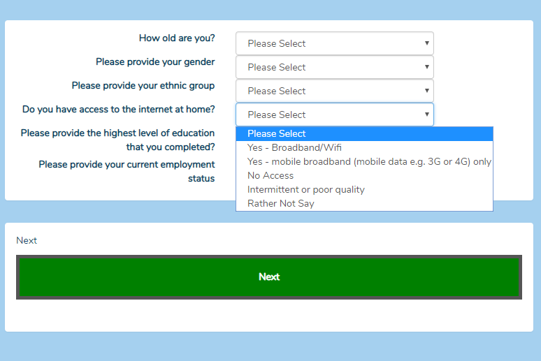
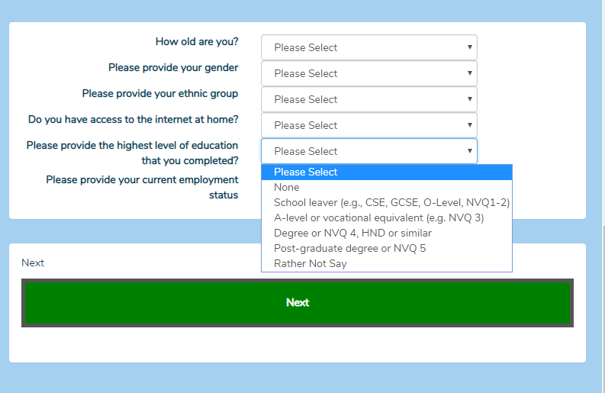
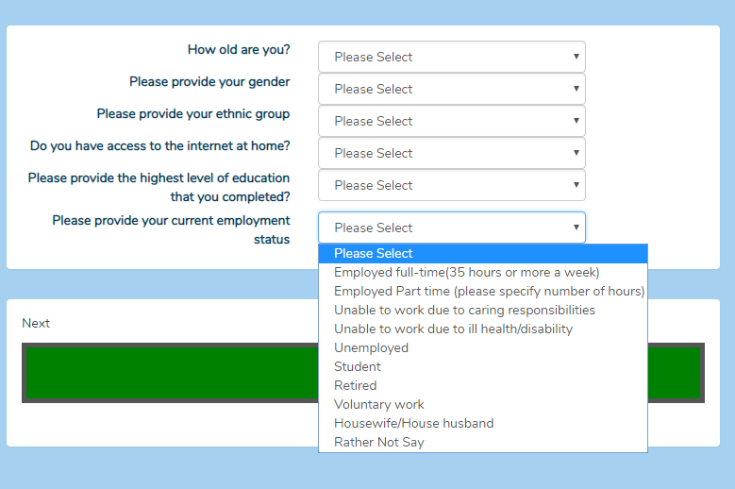
1.How old are you? [Please Select]
-16-20
-21-25
-26-30
-31-35
-36-40
-41-45
-46-50
-51-55
-56-60
-61-65
-66-70
-71-75
-76-80
-81-85
-86-90
-91-95
-96-100
-101-105
-106-110
2. Please provide your gender [Please Select]
-Female
-Male
-Other
-Rather Not Say
3. Please provide your ethnic group [Please Select]
-White
-English/Welsh/Scottish/Northern Irish/British
-Irish
-Gypsy or Irish Traveller
-Any other White background
-Mixed
-White and Black Caribbean
-White and Black African
-White and Asian
-Any other Mixed background
-Asian or Asian British
-Indian
-Pakistani
-Bangladeshi
-Any other Asian Background
-Black or Black British
-Caribbean
-African
-Any other Black background
-Other Ethnic Group
-Arab
-Any other ethnic group
-Rather not say
-Rather not say

4. Do you have access to the internet at home? [Please Select]
- YES – Broadband/Wifi
- Yes – mobile broadband (mobile data eg 3G or 4G) only
-No Access
-Intermittent or poor quality
-Rather Not Say

5. Please provide the highest level of education that you have completed? [Please Select]
-None
-School Leaver (e.g., CSE, GCSE, O-Level, NVQ1-2)
- A-level or vocational equivalent (e.g. NVQ 3)
-Degree or NVQ 4, HND or similar
-Post-graduate degree or NVQ 5
- Rather Not Say

6. Please provide your current employment status [Please Select]
- Employed full-time (35 hours or more a week)
- Employed part time (please specify number of hours)
-Unable to work due to caring responsibilities
-Unable to work due to ill health/disability
-Unemployed
-Student
-Retired
-Voluntary work
-Housewife/House husband
-Rather Not Say

